5:00pm WWF meeting before Commission meeting. Use the same zoom Link

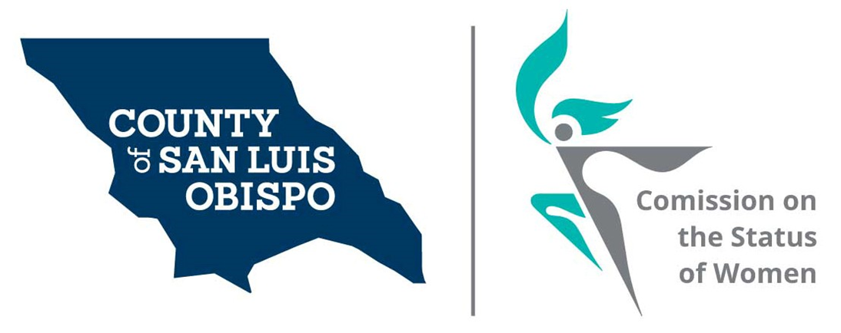
Meeting Agenda
April 6, 2021 @ 5:30 PM
Zoom meeting
- Call to Order

- Roll Call

- Guest(s), Introductions,

  - Intro of commissioners to new commissioners

- Public Comment

- Approval of Meeting Minutes for March

- Treasurer Report
  - Balance

- Commissioner Vacancies

  - District 5 - Debbie Arnold – One or two Commissioner needed
  - District 2 – Bruce Gibson – One Commissioner needed

- Social Media and other Communications (Stacy)
  - Newsletter
  - Resource’s page (Dixie)
- 2022 Women’s Wall of Fame (Meghan)
- Report from meeting with Supervisor Ortiz-Legg (Abrah and Andrea)

- Action On results of Survey (Stacy)
  - Cal Poly intern (Maria and Stacy)
  - Feminine Hygiene Drive
  - Discuss how the Commission can support AB-367, which would enact the Menstrual Equality Act of 2021 (Andrea)

- Board of Supervisors Agenda Highlight. (Dixie)

- Adjourn

