5:00pm WWF Committee meeting before Commission meeting.
Use the same zoom Link
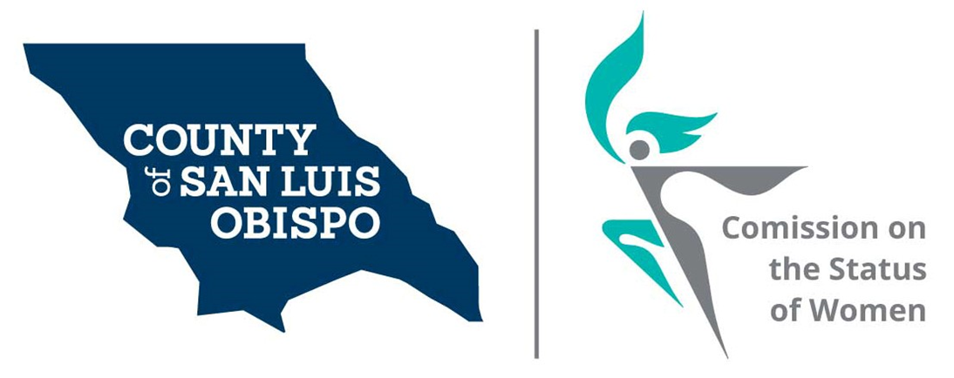
Meeting Agenda
- June 1 Discussion on adding girls to our commission.
, 2021 @ 5:30 PM
Zoom meeting
- Call to Order

- Roll Call

- Guest(s), Introductions,
  - Nina Negran (Brown Act presentation)

- Public Comment

- Approval of Meeting Minutes for April

- Treasurer Report
  - Balance

- NACW July in DC Conference

- Election of officers

  - Chair- Andrea Chmelik
  - Treasurer-Shirley Summers
  - Secretary- Debbie Geaslen
- Commissioner Vacancies
  - District 5 - Debbie Arnold – One or two Commissioner needed
  - District 2 -Bruce Gibson – One Commissioner needed
  - District 1-John Peschong – One Commissioner needed

- 2022 Women’s Wall of Fame (Meghan)

- Social Media and other Communications (Stacy)
  - Newsletter (Andrea)
  - Resource’s page (Dixie)
  - Website (Fanny and Stacy)
- Action On results of Survey (Stacy)
  - Feminine Hygiene Drive (Lets End Period Poverty) August 29, 2012
- Annual report and walking the Halls (Paulla and Shirley)
- Board of Supervisors Agenda Highlight. (Dixie)
- Report on ACCW Booth Camp
- Discussion on adding girls to our commission.

- Adjourn

