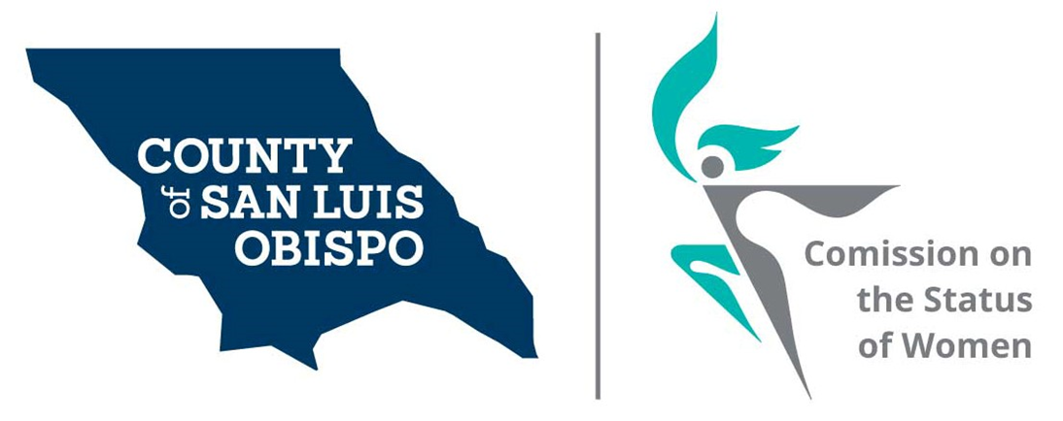
Meeting Agenda
February 2, 2021 @ 5:30 PM
Zoom meeting
- Call to Order

- Roll Call

- Guest(s), Introductions,

- Public Comment

- Approval of Meeting Minutes for January

- Treasurer Report
  - Balance
  - Budget to supervisors

- Friends of the Commission

- Commissioner Vacancies – SS
  - District 3 - Adam Hill - Two Commissioner needed
  - District 5 - Debbie Arnold – Two Commissioner needed
  - District 2 – Bruce Gibson – One Commissioner needed

- Social Media and other Communications (Stacy)
  - Website Resource page.

- Action On results of Survey (Stacy)

- Women’s Issues Survey Numbers Update (Meghan)
  - Update on results of 2020 survey
  - Form the committee for 2022 survey

- Board of Supervisors Agenda Highlight. (Dixie)

- 2022 Women’s Wall of Fame

- Adjourn

