5:00pm WWF meeting before Commission meeting.
Use the same zoom Link
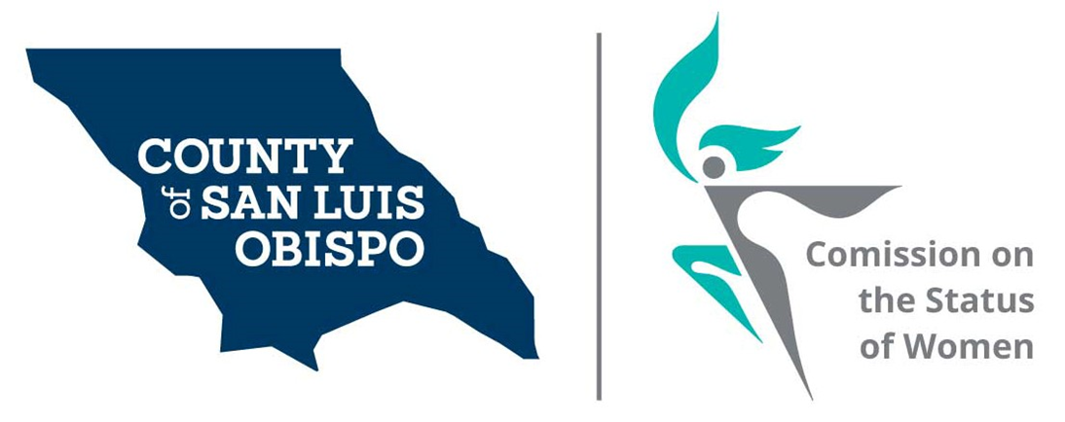
Meeting Agenda
May 4, 2021 @ 5:30 PM
Zoom meeting
- Call to Order

- Roll Call

- Guest(s), Introductions,

  - Sarah Sartain, legislative assistant to Supervisor Ortiz-Legg

- Public Comment

- Approval of Meeting Minutes for April

- NACW July in DC Conference

- Discussion on adding girls to our commission.

- Nomination for officers (election in June meeting)

  - Chair
  - Treasurer
  - Secretary

- Treasurer Report
  - Balance

- Commissioner Vacancies

  - District 5 - Debbie Arnold – One or two Commissioner needed
  - District 2 – Bruce Gibson – One Commissioner needed

- Social Media and other Communications (Stacy)
  - Newsletter (Andrea)
  - Resource’s page (Dixie)
  - Website (Fanny and Stacy)
- 2022 Women’s Wall of Fame (Meghan)

- Action On results of Survey (Stacy)
  - Cal Poly intern (Maria and Stacy)
  - Feminine Hygiene Drive (Lets End Period Poverty) August 29, 2012
  - Discuss how the Commission can support AB-367, which would enact the Menstrual (where do we go now) Equality Act of 2021 (Andrea)
- Annual report and walking the Halls (Paulla and Shirley)
- Board of Supervisors Agenda Highlight. (Dixie)
- Next meeting speaker on the Brown Act

- Adjourn

