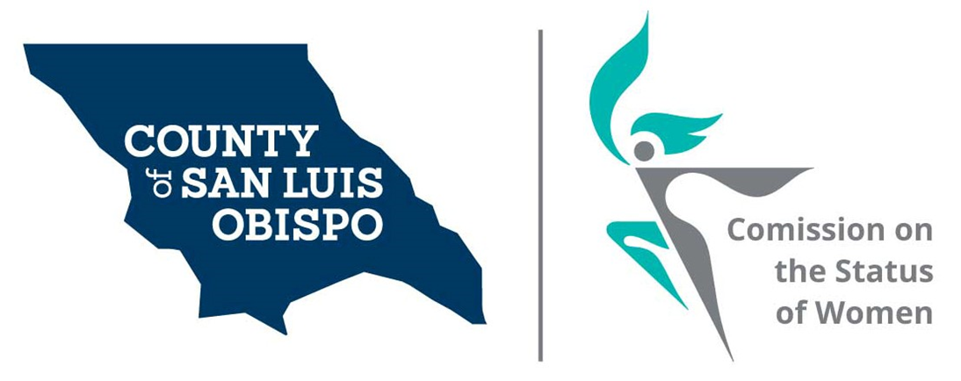

Report of 2019 Activities

Presented to the San Luis Obispo County
Board of Supervisors

April 21, 2020

By

Paulla Ufferheide, Chair

Table of Contents

Commission History 3
- Mission Statement
- 45th Anniversary

Current Roster 4

2019 Commission Activities 5
- Community Outreach

2019 Commission Events 6
- Women’s Wall of Fame

Commission Support Organizations 6
- National Association of Commissions for Women
- Association of California Commissions for Women

Commission Budget
- Funding Concerns 7
- Thriving Commission 8
- Sustaining Commission 9

About the Women’s Issues Survey 10

2019 Women’s Issues Survey Results 11

Commission History

Established on May 5, 1975 by Board of Supervisors Heilman, Willeford, Kupper, Mankins and Krejsa, the San Luis Obispo County Commission on the Status of Women is an advisory board to the County Board of Supervisors. Our charge is to help understand the issues facing women and girls in our county, and to share that information with the Board of Supervisors. The primary way we do this is through our Women’s Issues Survey.

Mission Statement

- Advocate for equal rights and for the agencies and programs that support the health, socioeconomic, and professional wellbeing of women and girls in our communities.

- Enhance the quality of women’s lives by identifying key issues that face women in our County and recommend solutions for those issues.

- Facilitate action by sponsoring projects and by serving as the coordinating body for the various community organizations that are dedicated to women and girls.

- Our primary goal is to increase collaborative efforts among County groups to influence public policy.

45th Anniversary

In the year 2020, the Commission will be celebrating its 45th year of representing the needs of women and girls within our County and reporting those needs to the County Board of Supervisors. A committee of Commissioners is being created to celebrate our 45th year through community outreach and creating free events, to address needs identified by our survey results, that implement solutions for the current issues affecting women.

Current COSW Roster

District 1: Meghan Madsen, Nancy Fiske and Dr. Maria Escobedo

District 2: Paulla Ufferheide, Dixie Walker, one vacancy

District 3: Andrea Devitt, Beverly Abrah Younger*, and one vacancy

District 4: Kathy Veder, Lorna Glenn and Stacy Meko

District 5: Shirley Summers, and two vacancies

Current COSW Officers

- Chair = Paulla Ufferheide, District 3
- Vice-Chair = Kathy Veder, District 2
- Treasurer = Shirley Summers, District 5
- Secretary = Beverly Abrah Younger, District 3

Commissioners Status

2019 was an important time of rebuilding our commission. In mid-2019, we had a sudden resignation of our Chair, and soon after that three more commissioners resigned. There was no one reason for the turnover; each had a personal reason. The second half of the year was focused on bringing in new commissioners and bringing them up to speed. We used our retreat this year to educate the new Commissioners and to establish goals for 2020 - 2021

* commissioner application pending

2019 COSW Activities

Website – www.slowomen.org
- Update to website in 2020 for better navigation, resources and look
- Online access to our survey available both in English and Spanish
- Printable surveys also available in English and Spanish
- Links to local governmental and health and human services websites
- Outreach/partnerships/events linked on our home page
- Women’s Wall of Fame forms, nominees, and winners now located on the site
- In 2020 we will be updating our website to make the website more user friendly.

Social Media
- Shared our survey and access to information, articles, data, and tools that relate to survey responses and women’s issues on:
- Facebook
- LinkedIn
- Twitter
- Instagram
- NextDoor
- Shared local free and low fee seminars related to women’s issues with followers

Community Outreach
- Guest speakers attended meetings throughout the year. Speakers are used to educate the Commissioners, leverage partnerships with other community agencies and businesses, to open up dialogue, and to gain data and details on the needs of women and girls in our communities.
- Hosted a booth at the SLO Women’s March / Call to Action Alley where we successfully captured 200 surveys from a wide variety of ages, socioeconomic backgrounds, and ethnicities of women and girls in our County.
- Honored 17 women from throughout the County at our 6th Annual Women’s Wall of Fame. One of the winners is now a Commissioner. This is the second year in a row during which our event inspired already highly busy community-oriented women to volunteer their time and knowledge to the Commission.

2019 Commission Events

- 6th Annual Women’s Wall of Fame – March 9, 2019.
- Theme: “Women Who Lead.”
- Keynote speaker: Delaine Eastin, former two term California State Superintendent.
- Over 200 women and men attended.
- 17 women were nominated. One winner in each of three categories, Volunteer, Business and Service was chosen by Commissioners from Contra Costa County Commission on the Status of Women

Commission Support Organizations

National Association of Commissions for Women (NACW)
NACW assists and supports Commissions for women to ensure that they not only survive but thrive. They provide valuable programs, meaningful activities, relevant resources and available expertise to member Commissions. Their network of state and local Commissions across the country exchange information, ideas, and best practices to support and guide Commissions.

The San Luis Obispo County Commission on the Status of Women is a member of NACW. We have formed alliances with national partners and built relationships with other Commissions who are looking to promote equality and justice for all women and girls, and to ensure they are represented and empowered in their communities.

Each year they hold an annual conference where national and local women’s issues are reviewed and discussed, and practical tools and resources are provided. Last year’s event was held in Los Angeles, where the Commission networked with other National Commissions, learned new ways to advocate effectively for women, and were provided tools and briefings on key women’s issues.

Currently Commissioner Kathy Veder, District 4, sits on NACW’s Board.

Association of California Commissions for Women (ACCW)
ACCW promotes viability, strength, and effectiveness of Commissions by encouraging them to advise elected officials about key issues and initiatives that affect women and girls within their local area, and within the State of California. They strive to help Commissions to receive funding by local Government and to give the women and girls of California a voice. Their objective is to develop a Statewide agenda on issues of concern and to ensure implementation of key policy and legislative changes to address those concerns.

Association of California Commissions for Women (ACCW)
Continued

ACCW holds a conference yearly during which local and statewide women’s issues are reviewed and discussed, and tools and resources are provided. Last year’s meeting was held in Los Angeles where two Commissioners attended.

Currently Commissioner Shawna Scott, District 5, sits on ACCW’s Board.

Commission Budget

Funding Concerns
The commission cannot do the work that they do without adequate funding. We encourage the Supervisor to include the following allocation in 2021’s budget (see the following page). Without the following funds, we would need to spend much of our time raising money, rather than successfully achieving our important goals.

Please see the 2021 Annual Budget below.

Annual Budget

Thriving Commission: $9,525.00
EXPENSE | AMOUNT
Dues
National Association of Commissions for Women (NACW) | $ 100.00
Association of California Commission for Women (ACCW) | $ 50.00
Community Outreach
Survey Monkey | $ 300.00
5th Annual Women’s Wall of Fame Event - March 2018 | $ 3,800.00
“Women’s Way to…” Events | $ 1,000.00
Conventions and Meetings
NACW (registration and two nights lodging) | $ 1,500.00
Annual Retreat | $ 125.00
Public Hearings/Meetings within State (CA Vet, ACCW, other CA Commissions | $ 500.00
Operational Costs
Printing/Reproductions (Survey, Brochure) | $ 500.00
Website Management (including Cyber Security) | $ 1,000.00
Postage | $ 100.00
Telephone Line/County Voicemail | $ 50.00
Badges/Name Tags/Business Cards | $ 100.00
Advertising (Public Notices) | $ 400.00
TOTAL | $9,525.00

Sustaining Commission: $4,450.00
EXPENSE | AMOUNT
Dues
NACW | $ 100.00
ACCW | $ 50.00
Conventions and Meetings
NACW (registration and two nights lodging) | $ 1,500.00
Annual Retreat | $ 100.00
Public Hearings/Meetings within State (CA Vet, ACCW, other CA Commissions | $ 500.00
Operational Costs
Printing/Reproductions (Survey, Brochure) | $ 300.00
Survey Monkey | $ 300.00
Website Management (with Cyber Security | $ 1,000.00
Postage | $ 100.00
Telephone Line/County Voicemail | $ 50.00
Badges/Name Tags/Business Cards | $ 50.00
Advertising (public notices) | $ 400.00
TOTAL | $ 4,450.00

About the Women’s Issues Survey

The survey was created to collect data and information regarding the needs and challenges facing women and girls in our County to share with the Board of Supervisors. Since 2015, we have used Survey Monkey to make it easier to compile survey response details to the Board. Responses can now be broken down by District and depicted in graph format for each of each Supervisor’s use.

As Commissioners attend events, volunteer, and interact with others, they share the power of letting their Board of Supervisors know their needs by sharing their voice and perspectives through the completion of our survey.

For the last three years, we have seen an increase in surveys primarily due to: 1) having a booth at SLO Women’s March Call to Action Alley. 2) through social media posts through multiple channels.

Our surveys have indicated year after year that the top concerns for women have been:
- Health Care
- Financial
- Affordable housing

Free events are created in support of the top issues women and girls are facing within our County. Examples include:
- Women’s Way to Health:
- Experts in their field are assembled to help attendees understand the resources available for them throughout the County such as:
- Health care related agencies and non-profits
- Mental health agencies
- Nutrition
- Dental
- Physical Fitness

- Women’s Way to Wealth:
- Experts in their field are assembled to share best practices and practical tools attendees can implement immediately such as:
- How to Take Good Care of Your Credit
- Wills, Trust, and How to Care for Your Family
- Budgeting and Investments
- Life, Disability, Long-Term Care and Rental/Home Insurance

2019 Women’s Issues Survey Results

The following is a summary of the 2019 Survey Results, with each question and its statistical findings shown below. A comparison to the 2018 survey findings is included.
- How do you rate the overall quality of life for you and your family here in San Luis Obispo county? (On a scale of 1 = Poor and 10 = Excellent.)

2018 2019
Rating: Percentage of Responses: Rating: Percentage of Responses
10 22% 10 8.82%
09 23% 09 16.88%
08 27% 08 27.58%
07 15% 07 18.89%
06 05% 06 7.18%
05 03% 05 5.04%
04 01% 04 2.77%
03 01% 03 2.02%
02 01% 02 .76%
01 01% 01 .25%

- How do you rate the overall quality of life for you and your Family here in San Luis Obispo?
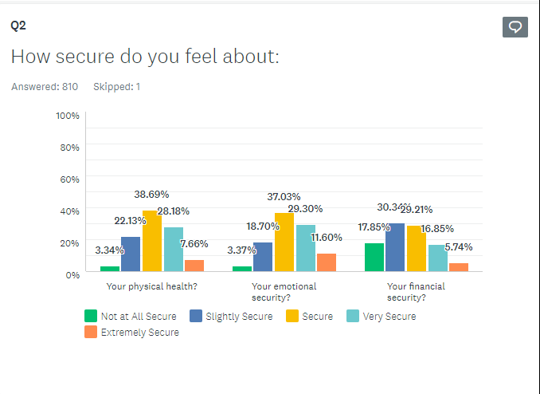

- Which of the following issues are you dealing with right now? (Top 5)

Answer: Percentage:
Financial Security 40%
Health Issues 29%
Affordable Housing/Lack of Housing 35%
Mental Health 23%
None 20%

- What type of programs and services would you like? (Top 5)

Answer: Percentage:
Senior Issues 33%
Health Issues 35%
Financial Planning 34%
Education 24%
Birth Control 26%
Childcare 20%

- What are the barriers, if any, preventing you from getting help you may need? (Top 5)

Answer: Percentage:
Don’t know what’s available 38%
Finances 32%
Don’t know how to access 19%
Intimidated/Hesitant to ask for help 16%
None 28%

- What is the best way for you to receive information about future programs and services?

- Which of the following describes your current employment status?

- What is your current occupation? (Top 10)

Answer: Percentage:
Retired 13%
Nurse 06%
Teacher 06%
Student 06%
Manager 03%
Business Owner 03%
Educator 03%
Assistant 03%
Engineer 02%
Sales 02%

- If retired, what was your occupation? (Top 5)

Answer: Percentage:
Nurse 12%
Teacher 10%
Educator 07%
Business Owner 03%
Director 02%

- What are your hobbies/interests?

Answer: Percentage:
Reading 66%
Travel 61%
Exercise 47%
Hiking 55%
Cooking 51%
Arts/Crafts 46%
Volunteering 44%
Music 47%
Gardening 45%
Camping 38%
Internet 22%
Swimming 21%
Games/Cards 23%
Writing 16%
Sewing 17%
Other (Dance, tennis, horseback riding 13%
Hunting, weaving)
Golf 03%

- How is your health care funded?

Answer: Percentage:
Employer 47%
Medicare 22%
Self-Funded 15%
Spouse/Partner 13%
Parents 8.0%
Affordable Care Act 5.0%
Medi-Cal 7.0%
I have None 2.0%
Military 1.0%

- Please select your District’s Board of Supervisor representative:

- How well do you think your Supervisor represents you?

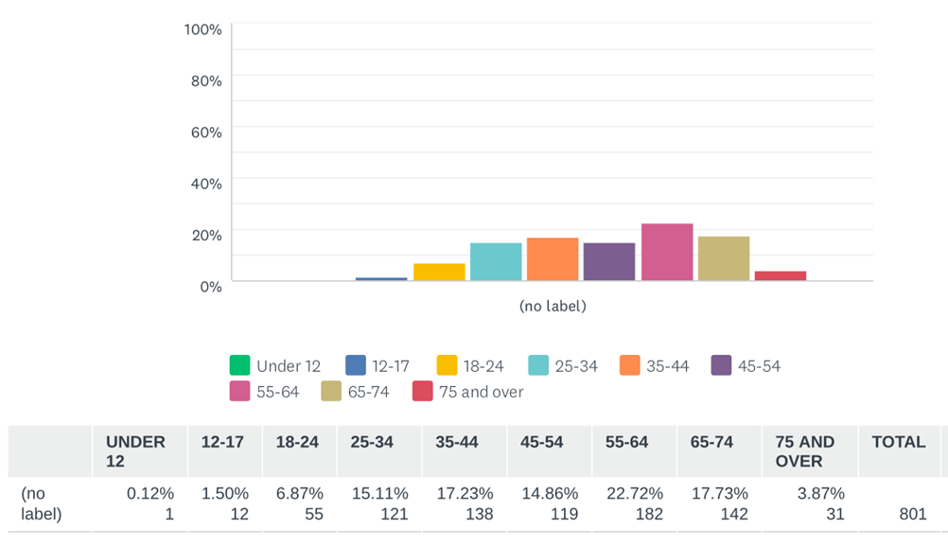
- What is your age?

- Where do you currently live?
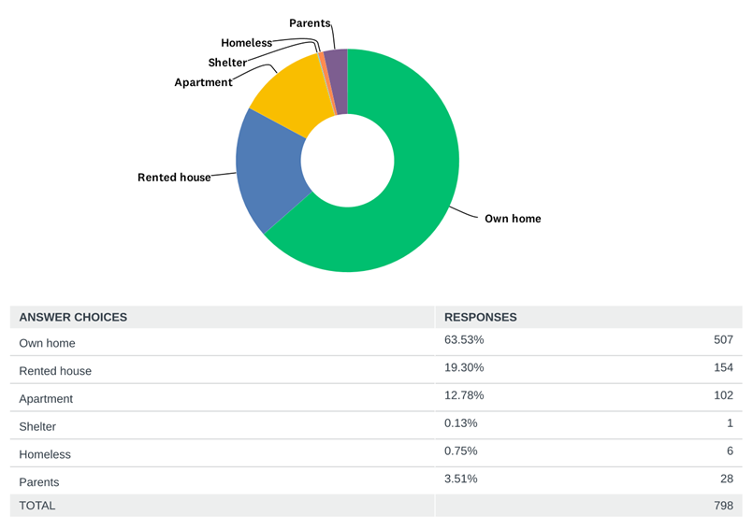

Continued

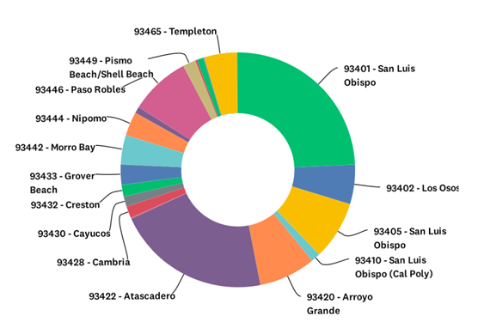
What is your zip code?

Continued

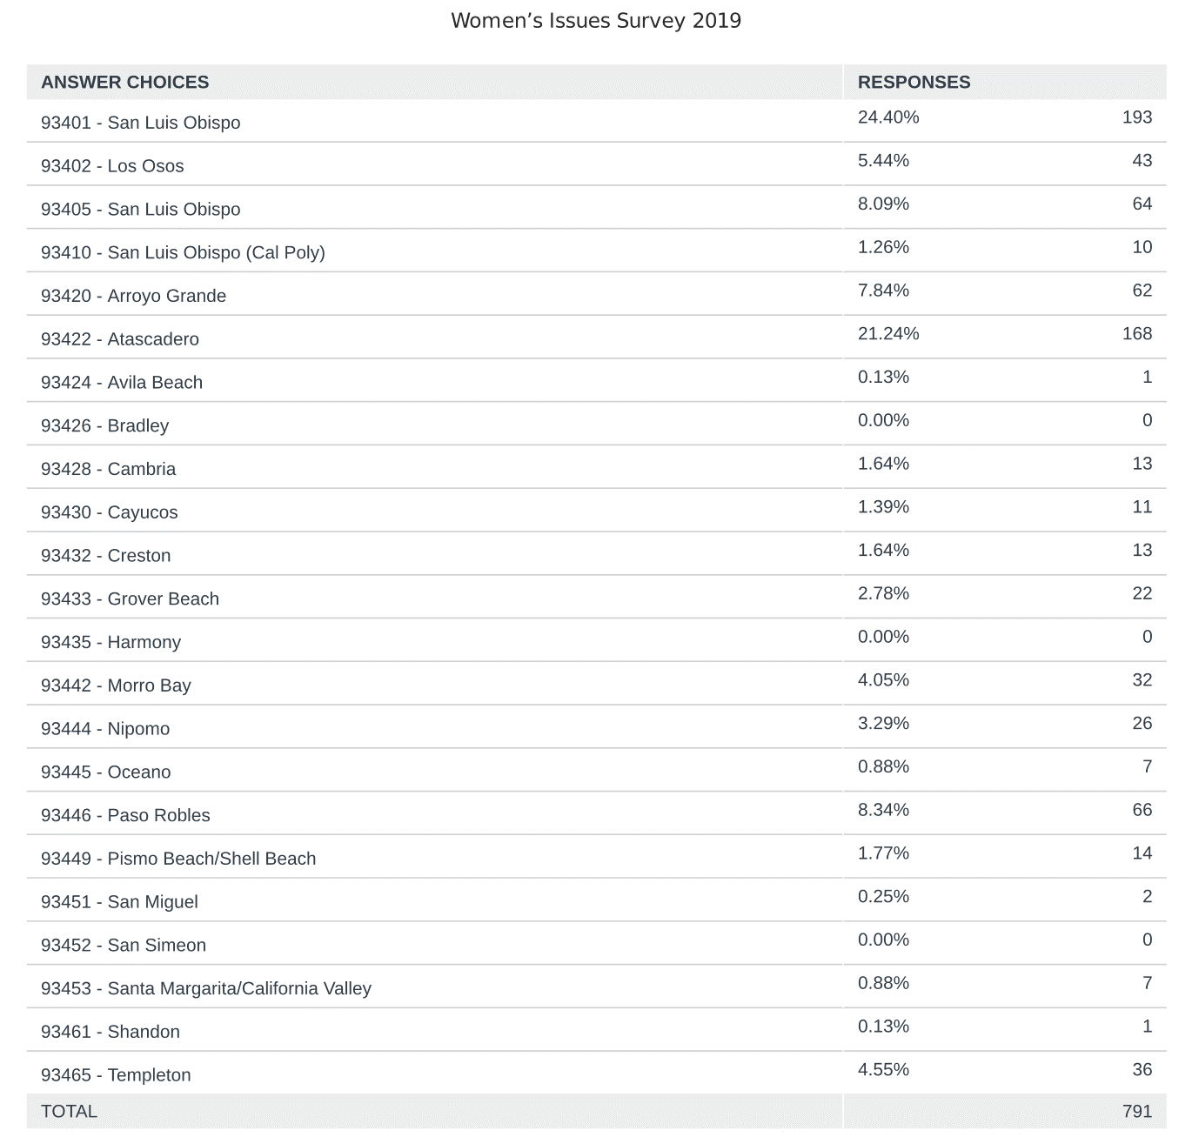
What is your Zip Code?

Continued

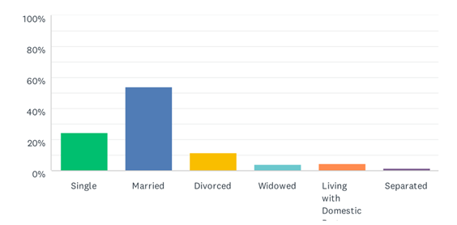
What is your marital status?

Continued

- What are the age range(s) of your children and how many in each range(s)?
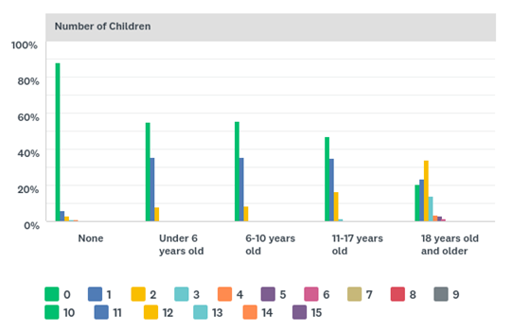

- What is your race/ethnicity?
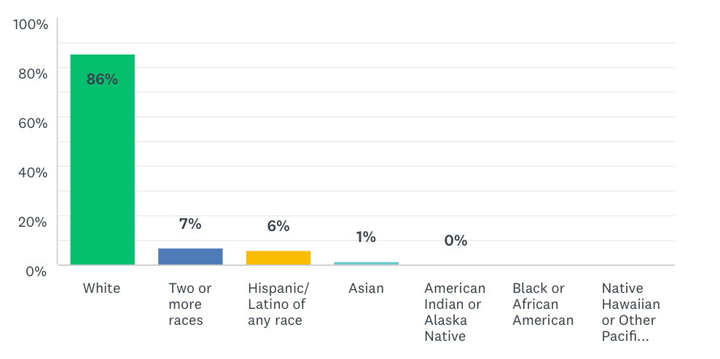

Continued

- What is your highest level of education?

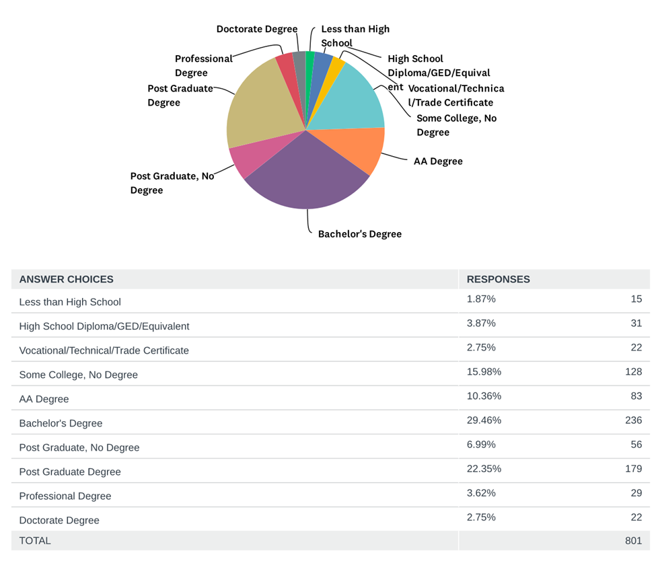

Continued

- What is your personal annual income?

