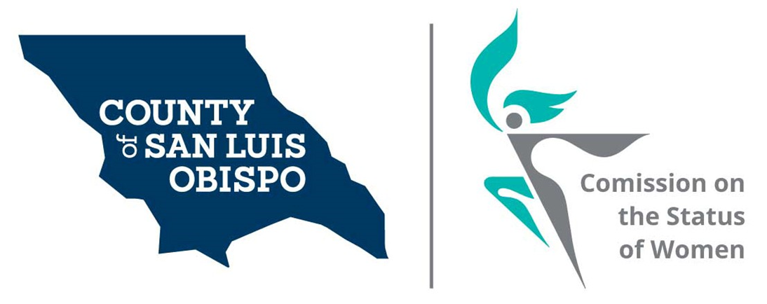
Meeting Agenda
March 2, 2021 @ 5:30 PM
Zoom meeting
- Call to Order

- Roll Call

- Guest(s), Introductions,

  - Intro of commissioners to new commissioners

- Public Comment

- Approval of Meeting Minutes for February

- Treasurer Report
  - Balance
  - Budget to supervisors?

- Commissioner Vacancies – SS
  - Dawn Ortiz-Legg - One Commissioner needed
  - District 5 - Debbie Arnold – Two Commissioner needed
  - District 2 – Bruce Gibson – One Commissioner needed

- Social Media and other Communications (Stacy)
  - Website Resource page.

- Action On results of Survey (Stacy)
  - Cal Poly intern (Maria and Stacy)
  - Feminine Hygiene Drive

- Women’s Issues Survey Numbers Update (Meghan)
  - Update on results of 2020 survey
  - Form the committee for 2022 survey
    - Set meeting to start review.

- Board of Supervisors Agenda Highlight. (Dixie)

- 2022 Women’s Wall of Fame (Meghan)

- Adjourn

