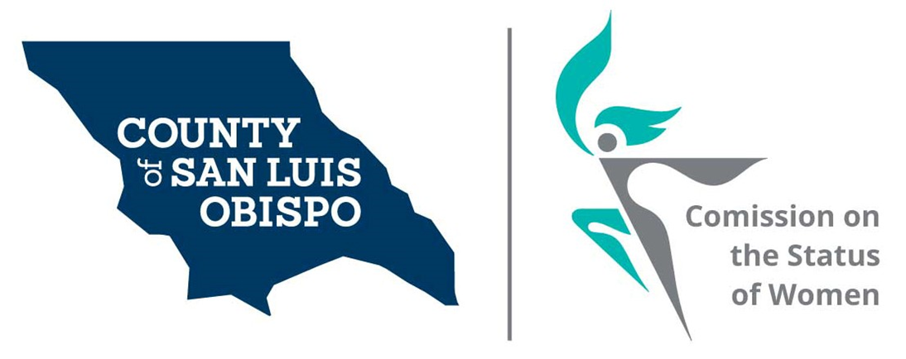

Report of 2020 Activities

Presented to the San Luis Obispo County
Board of Supervisors

April 20, 2021

By

Paulla Ufferheide, Chair

Table of Contents

Commission History 3
- Mission Statement
- 45th Anniversary

Current Roster 4

2020 -2021 Activities 5
- Community Outreach
- Commissioner education.
- Feminine Hygiene Drive for 2021
- Planning for Women Wall of Fame 2022
- Survey

Commission support organizations 7
- National Association of Commissions for Women
- Association of California Commissions for Women

Commission Budget 8
- Thriving Commission
- Sustaining Commission

Commission History

Established on May 5, 1975 by Board of Supervisors Heilman, Willeford, Kupper, Mankins and Krejsa. The San Luis Obispo County Commission on the Status of Women is an advisory board to the County Board of Supervisors. Our charge is to help understand the issues facing women and girls in our county and to share that information with the Board of Supervisors. The primary way we do this is through our Women’s Issues Survey and presentations from groups in our county working on women issues.

Mission Statement

Advocate for equal rights and for the agencies and programs that support the health, socioeconomic, and professional wellbeing of women and girls in our communities.

Enhance the quality of women’s lives by identifying key issues that face women in our County and recommend solutions for those issues.

Facilitate action by sponsoring projects and by serving as the coordinating body for the various community organizations that are dedicated to women and girls.

Our goal is to increase collaborative efforts among County groups to influence public policy.

45th Anniversary

In the year 2020, the Commission celebrated its 45th year of identifying the needs of women and girls within our County and reporting those needs to the County Board of Supervisors. A committee of Commissioners was created to celebrate our 45th year through community outreach and putting on free events that support survey results indicating current issues affecting women. This and the celebration of 100 years of the women’s right to vote were canceled due to the pandemic. We are looking forward to our 50th year which we, hopefully, will be able celebrated in 4 years.

Current Roster

District 1: Meghan Madsen, Nancy Fiske, and Dr. Maria Escobedo

District 2: Paulla Ufferheide, Dixie Walker, one vacancy

District 3: Andrea Chmelik, Beverly Abrah Young, and Victoria Condor-Williams

District 4: Kathy Veder, Debbie Geaslen and Stacy Meko

District 5: Shirley Summers, Franny Arenas, one vacancy

- Chair = Paulla Ufferheide, District 3
- Vice-Chair = Kathy Veder, District 2
- Treasurer = Shirley Summers, District 5
- Secretary = Debbie Geaslen, District 5

Commissioner Status
The Commission on the Status of Women for San Luis Obispo County Held all there meeting this year, even though in March we had to go to Zoom meetings. In 2020 we worked at getting our commission’s vacancies filled. Besides Supervisors appointing Commissioners, we had a good surprise when we were working on our contact list for our Women’s Wall of Fame. Each Commissioner contacted part of the list. It had a great effect. As the commissioners contacted these groups, people learned about the commission and wanted to attend our meetings. Some have applied to become commissioners.
A large part of this year was spent working in groups to examine and developing new ideas on how the commission is going to proceed going forward during the recovery from this Pandemic.
We also focused on conducting orientation for our new commissioners. We used our retreat in February 2020 (which was our last in-person meeting) to educate the new Commissioners and began establishing new goals for 2020 - 2021

2020-2021 Activities
We moved forward with as many events as possible until COVID constraints made them not viable.

Website – www.slowomen.org
- Update to website
- Online access to our survey available both in English and Spanish. This year we had very few responses because many organizations were not active enough to promote the online surveys.
- Printable surveys were also available in English and Spanish, but we were not able to get printed survey out this year because of COVID in-person protocols.
- Outreach/partnerships/events linked on home page
- Women’s Wall of Fame forms are located on the site, but event had to be canceled.
Social Media
- Shared information on the activities of the commission, articles, data, and tools that relate to survey responses and women’s issues on:
- Facebook
- LinkedIn
- Twitter
- NextDoor
- Shared local free and low fee seminars related to women’s issues with followers.

Community Outreach
Guest speakers attended Zoom meetings throughout the year. Speakers are used to educate the Commissioners, build partnerships with other community agencies and businesses, and to open dialogue, gain data and develop details on the needs of women and girls in our communities.

February, Monica Anderson, Community Action Partnership, 2-1-1 Community Resource Specialist

March, Susan Carter, cofounder of North County Abolitionist

June, Restorative Partners managers and staff, Sister Theresa Harpin, Founder and CEO

July, Becky Gray, Executive Director of “MUST” Charities, presented to the SLO Council on the Status of Women on this date.

August, Briana Fox, Women’s league from the SLO Community Foundation. Her presentation was titled “What Do Women Need: Issues Impacting Women & Girls in San Luis Obispo County, 2020.”

September, Dr. Leola MacMillan, Director, Resource Development, United Way of SLO

October, SLO Branch NAACP Cheryl Vines & Steve Vines

2020 Commission Events

- 7th Annual Women’s Wall of Fame – 2020-2021.
Worked on this event for 2020 and 2021 but they had to be Canceled. We are now planning the 2022 event. It will be held at the Madonna on March 19, from 12:00-2:00

About the Women’s Issues Survey

The survey was created in 2010 to collect data and information regarding the needs and challenges facing women and girls in our County. We share the results with the Board of Supervisors. Since 2015, we have used Survey Monkey to make it easier to compile survey response details to the Board.
We are not reporting on our survey this year because of the number of surveys (252) were too low to report, (In 2019, 833 survey were completed) primarily due to in-person constraints.
Although the number of physical surveys was reduced, we spent the time improving the process for when the constraints are removed. The Commission established a group of commissioners that looked at the process used for our survey. Using some expert advice this group developed some new ways to conduct our survey in the future.
- We have used our survey and other studies to develop a list of concerns that we think would be valuable for us to study. We have had a meeting with Cal Poly to develop a focus group structure. We will be working with Jasna Jovanovic, Professor, Psychology of Child Development also Jean M. Williams, Professor of Women’s Studies.
- We plan to do our Survey every other year. This will give us the year in between to develop and act on significant results with focus groups, seminars, and other events. At the same time new subject issues will be addressed with similar mechanisms. This will introduce the subjects for the next survey.
- Attached are the concepts for these focus groups (See attachment A). Your Commissioner will be setting up an appointment (if they have not yet) to go over some of these ideas and get your input. This will be conducted in 2021.
- We will be reworking our survey to focus on concerns that are affecting women and girls in our county. Your Commissioners will be working with their Supervisor to help us define these questions.

Planned events as we go into 2021
Feminine Hygiene Drive (Let’s End Period Poverty)
August 26 Women’s Equality Day
  - According to the 2019 Alliance for Period Supplies report, 1 in 4 women in the United States struggles to purchase period products due to lack of income, and 1 in 5 low-income women reports missing work
  - A 2019 Harris Interactive poll of 2,000 U.S. teens aged 13 to 19 found that 84% have either missed class time or know someone who missed class time because they did not have access to period products,

  - Shirley Summers had discussions with ECHO Homeless Shelter regarding a second drive. ECHO thought that the first drive was successful and welcomes a second drive.
  - See attachment B to see plans for this event
Support for the California Assembly Bill (AB) 367, Menstrual Equity Act of 2021

National Association of Commissions for Women (NACW)

NACW assists and supports Commissions for women to ensure that they not only survive but thrive. They provide valuable programs, meaningful activities, relevant resources and available expertise to member Commissions. Their network of state and local Commissions across the country exchange information, ideas, and best practices to support and guide Commissions.
The 2020 confederacy was cancelled, but the 2021 NACW Event- July 18 – 22 is in Washington DC in-person/ Hybrid. We hope to send a commissioner to this conference.

Association of California Commissions for Women (ACCW)

The ACCW promotes viability, strength, and effectiveness of Commissions by encouraging them to advise elected officials about key issues and initiatives that affect women and girls within their local area and within the State of California. They strive to help new Commissions to be funded by local Government and to give the women and girls of California a voice. Their objective is to develop a Statewide agenda on issues of concern and to ensure implementation of key policy and legislative changes to address those concerns.
The 2020 ACCW meetings were cancelled
The ACCW June 26, 2021 Pasadena in person/ hybrid is still planned.

Need for County Budget
The commission cannot do the work that they do without some funding.
We would like to encourage the Supervisor to include the commission in your budget. Without a budget we need to spend much of our time raising money, writing grants, which impacts other commission work we could be doing.

Annual Budget

Thriving Commission: $9,571.00

EXPENSE | AMOUNT
Dues
National Association of Commissions for Women (NACW) | $ 100.00
Association of California Commission for Women (ACCW) | $ 50.00
Community Outreach
Survey Monkey | $ 300.00
5th Annual Women’s Wall of Fame Event - March 2018 | $ 3,800.00
 | $ 1,000.00
Conventions and Meetings
NACW (registration and two nights lodging) | $ 1,500.00
Annual Retreat | $ 125.00
Public Hearings/Meetings within State (CA Vet, ACCW, other CA Commissions | $ 500.00
Operational Costs
Printing/Reproductions (Survey, Brochure) | $ 500.00
Website Management (including Cyber Security) | $ 1,000.00
Postage (PO Box) | $ 146.00
Telephone Line/County Voicemail | $ 50.00
Badges/Name Tags/Business Cards | $ 100.00
Advertising (Public Notices) | $ 400.00
TOTAL | $9,571.00

Sustaining Commission: $3,696.00

EXPENSE | AMOUNT
Dues
NACW | $ 100.00
ACCW | $ 100.00
Conventions and Meetings
NACW (registration and two nights lodging) | $ 1,500.00
Annual Retreat | $ 100.00
Public Hearings/Meetings within State (CA Vet, ACCW, other CA Commissions | $ 500.00
Operational Costs
Printing/Reproductions (Survey, Brochure) | $ 300.00
Survey Monkey | $ 300.00
Website Management (with Cyber Security) | $ 250.00
Postage and PO mailbox 146.00 | $ 146.00
Advertising (public notices) | $ 400.00
TOTAL | $ 3,696.00

