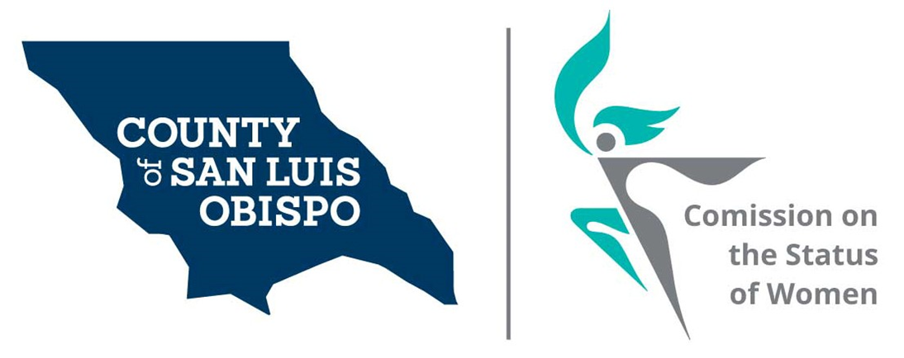
Meeting Agenda
January 5 @ 5:30 PM
Zoom meeting
- Call to Order

- Roll Call

- Guest(s), Introductions,

- Public Comment

- Approval of Meeting Minutes for November and December

  - New roster

- Treasurer Report
  - Balance
  - Budget to supervisors

- Friends of the Commission
- Nominations for Commissions officers
  - Nominations May
  - Election June

- Commissioner Vacancies – SS
- District 3 - Adam Hill - Two Commissioner needed
- District 5 - Debbie Arnold – Two Commissioner needed

- Social Media and other Communications (Stacy)

- Action On results of Survey (Stacy)

- Women’s Issues Survey Numbers Update (Megan)

  - Decision to host survey bi-annual

- Board of Supervisors Agenda Highlight. (Dixie)

- 2021 Women’s Wall of Fame (update) May 8th, 2021 at Madonna Inn in secret garden

- Adjourn

