5:00-5:30pm Women's Wall of Fame Committee meeting before regular Commission meeting

Use the same zoom link
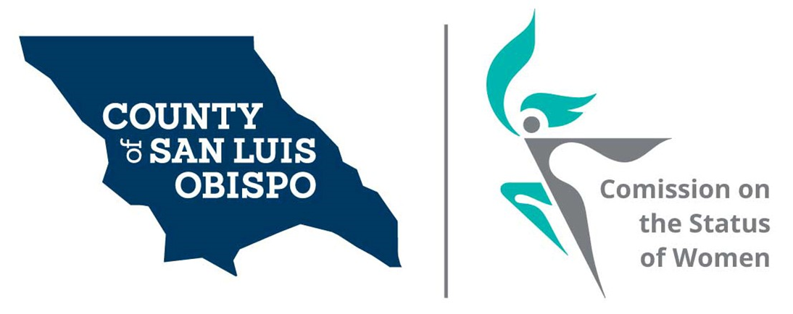

Meeting Agenda for the SLO County Commission on the Status of Women and Girls (SLOCOSWG)
October 5, 2021, 5:30pm
Zoom meeting (login below)

- Call to Order
- Roll Call
- Guests, Introductions
  - Emma Fay, CAPSLO Teen Wellness Coordinator
- Public Comment (limited to agenda items)
- Board of Supervisors Agenda Highlight (Commissioner Walker)
- Approval of meeting minutes for August 2021 and September 2021
- Commissioner Vacancies
  - District 2 – Bruce Gibson – one vacancy
  - District 3 – Dawn Ortiz-Legg – one vacancy
  - District 5 – Debbie Arnold – one vacancy
- Vice Chair nomination and election
- SLOCOSWG Women's Wall of Fame annual event update (Commissioner Madsen)
- Establishing Following Working Committees (vote)
  - Policy & Legislation – Chair Commissioner Chmelik
  - Impact of Covid 19 on Women and Girls in SLO County – Chair Commissioner Condor-Williams
- Update from the Policy & Legislation Committee (Commissioner Chmelik)
- Update from the Covid 19 Impact Committee (Commissioner Condor-Williams)
- Design and purchase of branded thank you cards (vote)
- Volunteer Coordinator (Commissioner Chmelik)
- Collaboration with AAUW on gender pay gap (Commissioner Chmelik)
- Resource pages listed on SLOCOSW website update (Commissioner Walker)
- Website update (Commissioner Meko & Arenas)
- Social media & Newsletter Update (Commissioner Chmelik)
- Adjourn

Zoom login
Topic: SLO County Commission on the Status of Women and Girls Monthly Meeting
Time: Oct 5, 2021 05:30 PM Pacific Time (US and Canada)

Join Zoom Meeting
https://us02web.zoom.us/j/84607089239?pwd=a1N2QkhXZytwaDB1bmVrT3dRYzByZz09

Meeting ID: 846 0708 9239
Passcode: 456251
One tap mobile
+16699009128,,84607089239#,,,,*456251# US (San Jose)
+13462487799,,84607089239#,,,,*456251# US (Houston)

Dial by your location
+1 669 900 9128 US (San Jose)
+1 346 248 7799 US (Houston)
+1 253 215 8782 US (Tacoma)
+1 312 626 6799 US (Chicago)
+1 646 558 8656 US (New York)
+1 301 715 8592 US (Washington DC)
Meeting ID: 846 0708 9239
Passcode: 456251
Find your local number: https://us02web.zoom.us/u/kcpZfYZsPK

